RHEL 9 For Ip change 1st method—

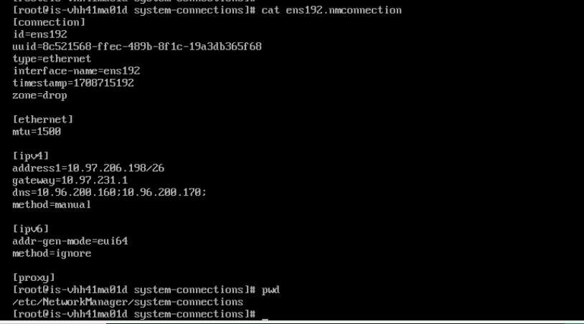

For Enable route login in RHEL9—

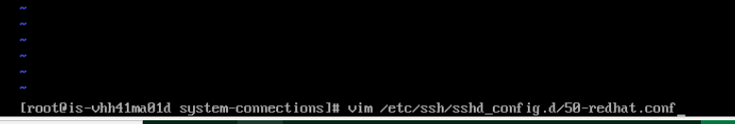

Add below line in above path--

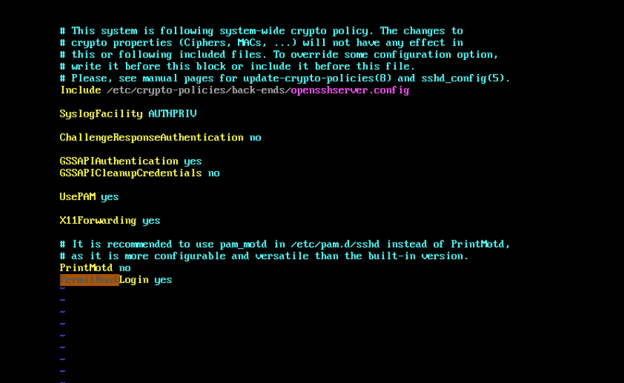

And restart sshd service.

2nd ip add method—

Ip add through NMCLI—

